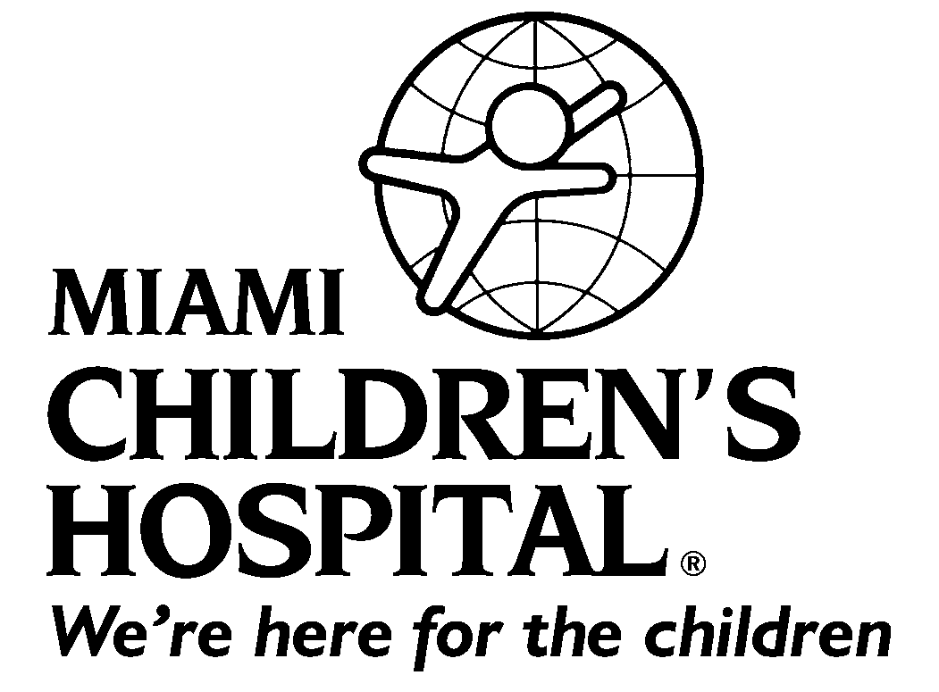

MIAMI CHILDREN’S HOSPITAL

CLINICAL OBSERVERSHIP AGREEMENT AND RELEASE

For International Medical Graduates
I, Dr./Mr./Ms. ______________________________ of ___________________________________
City/State ___________________________________Country __________________________in consideration of being allowed to participate in an observership (the "Observership") at Miami Children's Hospital ("MCH") do hereby agree that:
- I understand and agree that my Observership will be for a period of (minimum 4 weeks; maximum 3 months) __________________ from _____________ (dd/mm/yy) to ______________ ( dd/mm/yy ), and that it shall consist of observing the activities of (department/division) _____________________________ at MCH. At the end of such period, I understand that my Observership will cease and I will no longer be permitted access to MCH facilities.
- I understand that MCH will not be providing liability coverage and that, as a non-licensed International Medical Graduate (IMG), I may attend conferences, sit in with teams during rounds in a conference room setting, and may use the Medical Library with my MCH ID badge. I will not be involved in any patient contact activities or be present with patients without supervision. These Observership activities will not constitute clinical training. In no way will any letter or other document be generated to indicate or even suggest that this experience is considered clinical training.
- I understand that my Observership is for observation ONLY. I will not be permitted to actively participate in patient care or contact, examination, research or other work during the Observership. I understand and agree that my Observership is in no way an offer of or employment by MCH and that I shall not receive, nor be entitled to receive, any compensation, reimbursement or remuneration for my participation in my Observership. I further understand and agree that at no time will I be considered or deemed to be an agent, servant or employee of MCH, I further agree to release MCH from any and all claims to compensation, reimbursement or remuneration related to my Observership.
4. I agree that I will provide MCH with proof of valid legal status from the appropriate authorities for the term of my Observership and I agree to maintain and comply with all the requirements of such status for the duration of the Observership. I am able to speak and understand the English language.
5. I understand that I will be observing the activities at MCH and I therefore agree to act appropriately and in a professional, courteous manner during my Observership. I understand and agree that my Observership may be terminated by MCH at any time, with or without cause.
6. In the event my Observership involves observing direct patient care, I understand that such patients are entitled to confidentiality and I hereby agree not to disclose, discuss or reveal any details about such patients to anyone other than those involved in my Observership with me.
7. I acknowledge that I have insurance in my home country, including health insurance, which will cover my medical expenses (including repatriation, should that become necessary) in the event I become ill or injured in the United States during my Observership, and that I will be required to show proof of such insurance prior to arrival at MCH. If I do not have such insurance upon my arrival at MCH, I understand that I will be required to purchase such insurance at my own expense, prior to beginning the Observership.
8. I understand that I will complete all required paperwork as listed on the Credentials Checklist prior to the first day of my Observership. I understand that I will be required to provide proof that I have been tested for tuberculosis and have had the mandatory immunizations as required by MCH. I will arrive at the MCH Medical Education office the first day of my Observership to receive my MCH badge and to complete my orientation requirements.
9. In consideration of my being allowed to participate in the Observership, I agree to indemnify MCH, its affiliates and their respective officers, directors, employees and agents, against and hold the same harmless from any and all claims, losses, damages, liabilities, actions, judgments, costs and expenses (including settlements, judgments, court costs and reasonable attorneys' fees and costs) of any nature or kind whatsoever, which I may have or accrue as a result of or arising out of my participation in the Observership, including airborne pathogens, whether caused by the negligence, action or inaction of MCH or otherwise. I also agree that I shall be fully responsible for any and all loss or damage that I inflict upon any person or upon MCH’s facilities during my participation in the Observership. I understand that this release is intended to be as broad and inclusive as is permitted by the laws of the State of Florida.

10. Have you ever been convicted of a criminal offence, charged with an offence, or are you at present, the subject of criminal charges? (circle one) YES / NO

If "yes" please provide the following details (answering “yes” to this question will not lead to automatic disqualification; however, failure to provide relevant information will lead to disqualification and/or termination of the Observership Program).

- Date(s) of conviction(s)/charge (s): _________________________________________________________
- Outcome of conviction(s)/charge(s): ________________________________________________________
- Please provide relevant details of the nature of the conviction(s)/charge(s): __________________________
_____________________________________________________________________________________________

IN WITNESS WHEREOF, the undersigned has signed this Observership Agreement on the ___ day of ___________________________, 20___.

__________________________________________________________________________________
Participant (print name)
__________________________________________________________________________________

Participant (sign name)
__________________________________________________________________________________

Medical Education Office Designated Official (sign name)

