What is a Key Driver Diagram?
A key driver diagram is a tool intended to help organize your ideas and discover various causes that contribute to the issue you are trying to improve. The key driver breaks down the aim of your project into primary and secondary drivers, and helps you determine what changes to make.
- Primary drivers are factors that are part of your system that directly impact the outcome, or aim, of your QI effort.
- Secondary drivers are the opportunities for change (interventions) in your QI effort. They directly impact the primary driver of your aim.

Does my diagram have to look exactly like the one provided?
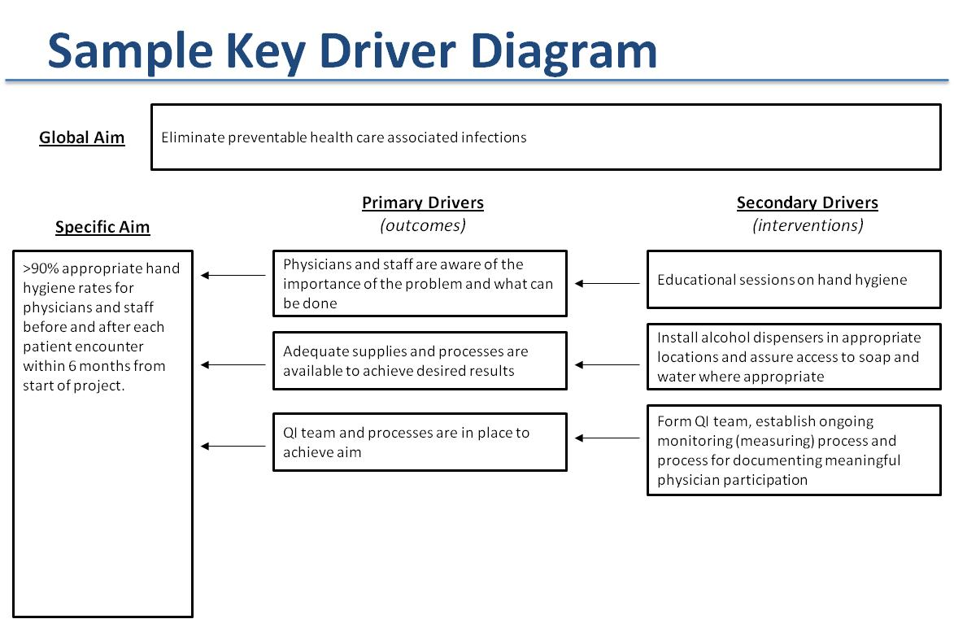
No. This is just a tool and may be modified based on the nature of your MOC project and/or discussions in your QI team.

How does this relate to measures?
Primary drivers are usually outcome measures and secondary drivers are usually process measures, though this is not always the case.

What is the benefit of a key driver diagram?
It quickly identifies the important aspects of your QI effort by explicitly defining the logic behind your improvement effort. In identifying the aim, you must identify what you want to change or improve (primary drivers) and how you will improve (secondary drivers or interventions). The diagram, when read right to left indicates that if you perform the secondary drivers (interventions) then the primary drivers will improve, and the improvement of the primary drivers will satisfy the aim.

Key Driver Diagram
Global Aim
Click here to enter text.

Primary Drivers Secondary Drivers
Specific Aim (outcomes) (interventions)
Click here to enter text.
Click here to enter text.
Click here to enter text.
Attributes of a good aim statement:
- Specific
- Measurable
- Actionable
- Realistic
- Timely

Click here to enter text.
Click here to enter text.

Click here to enter text.

Click here to enter text.

Click here to enter text.
Click here to enter text.

Click here to enter text.
Click here to enter text.

Click here to enter text.
Instructions: Click in the boxes above to enter your MOC Projects Aims and Drivers. Directional arrows may be moved. Delete this box (and attributes of a good aim statement) once you’ve completed your diagram.

