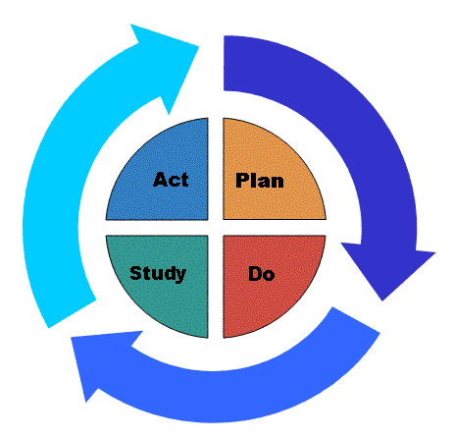

MODEL FOR IMPROVEMENT
PDSA Planning Worksheet

DEPARTMENT OF MEDICAL EDUCATION
“Practice-Based Learning and Improvement”

Project Title:
Resident(s)/ Fellow(s): Faculty Mentor(s):

Project #: PDSA #
Cycle dates: to

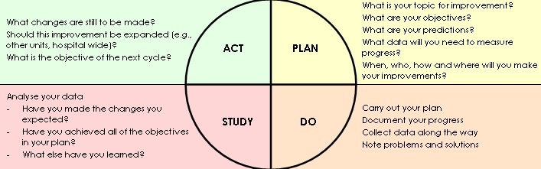

PLAN

- AIM: (Describe the change you are testing and state the question you want to answer with this test.)

Create a “Global Aim Statement” for this project (What are we trying to accomplish?)

Create a specific “S.M.A.R.T. Aim Statement” for this cycle

List 2 stakeholder (at least) who should be included early in the process

DO

- Measure(S): (Carry out the change or test; collect data and feedback. Describe what happened include reporting of any unexpected events. Begin analysis.)

Decide on the Measure(s): List the measure(s) that you will be measuring: (Minimum ONE measure)

Measure#1:
Is this a: Process Measure Outcome Measure Balancing Measure (Check one)

Measure#2:
Is this a: Process Measure Outcome Measure Balancing Measure (Check one)

Measure#3:
Is this a: Process Measure Outcome Measure Balancing Measure (Check one)

What process will you follow in your method? (# of charts reviewed? Events counted?)

How will we know that the change is an improvement?

- Intervention(S): What changes can we make that will result in improvement? What will be your intervention(s)? What would be the most effective way to introduce the intervention(s)? (Training, changing of process, editing EMR, adding alerts)

PS: You may use the “Key Driver” document to guide you for Steps 1-3

STUDY

- Analyse the measures: (Complete analysis of data; summarize what was learned; compare your results to your predictions. What did you learn? Any surprises?) – You may attach graphs/ tables on a separate sheet.

ACT

- What’s next? (Are you ready to implement the change you tested? Modifications or refinements for the next cycle; what will you do next? Plan for next cycle) – Did you reach your SMART aim? Why or why not?

