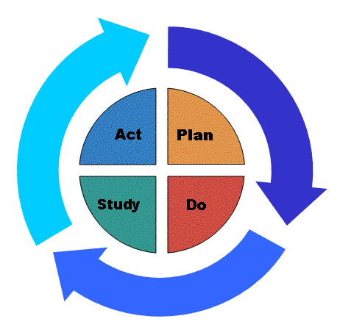

MODEL FOR CME ACTIVITY IMPROVEMENT
PDSA Worksheet

CME ACTIVITY IMPROVEMENT REPORT

“Practice-Based Learning and Improvement in CME”

Instructions: This reporting form is to be completed by the Chair of the CME activity and submitted to the CME Committee not later than 4 months after activity completion

CME Activity Title:
CME Activity Date(s):

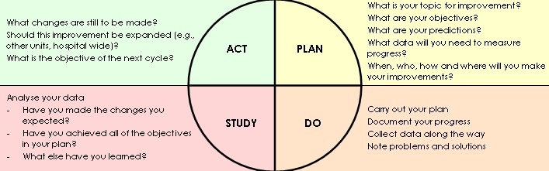

PLAN: (Describe the plan you used to plan your CME Activity) – (C2-C6; C11; C12; C13-C15)

What elements/factors you used to choose topics/ titles/ speakers? (C2-C6)

Plan for change: who, what, when, where? What changes were new? (C13-C15)

How will you measure the outcome? (C11)

Plan for collection of data: Who, What, When, Where? (C11-C12)

DO: (Carry out the event. Describe what happened include reporting of any unexpected events) – (C7-C10)

Study: (Complete analysis of data; summarize outcomes; summarize what was learned; compare your results to your predictions. What did you learn? Any surprises?) – What stood out as Positives and Areas for Improvement? (C11-C12)

Act: (Modifications or refinements for the next cycle; what will you do next? Plan for next cycle? What changes will you implement?) – C13-C15)

_____________________________________________________

Completed by:
Date:

For CME Committee Use Only:

Discussed/ Reviewed by CME Committee on (Date):

Comments/ Recommendations:

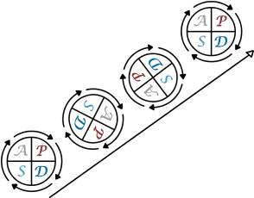

Planning Worksheet/PDSA

